# Assignment -1

Python Programming

|  |  |
| --- | --- |
| Assignment Date | 19 SEPTEMBER 2022 |
| Student Name | SRIJISH R |
| Student Roll Number | 1905138 |
| Maximum Marks | 2 Marks |

# Question-1:

1. Create registration page in html with username, email and phone number and by using POST method display it in next html page.

# Question-2:

1. Develop a flask program which should contain at least 5 packages used from pypi.org

**Note: -** Following application contains (Flask, render_template, url_for, redirect,request) So both Questions have same Answers

# Source Code: App.py

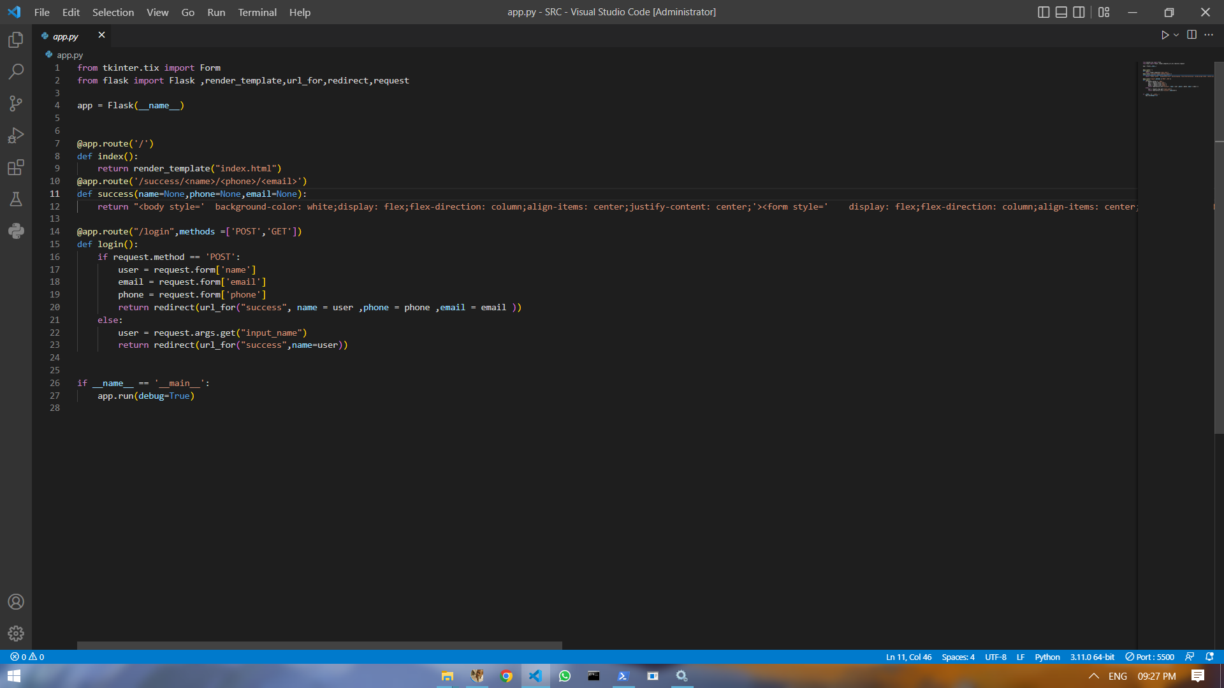

**index.html**

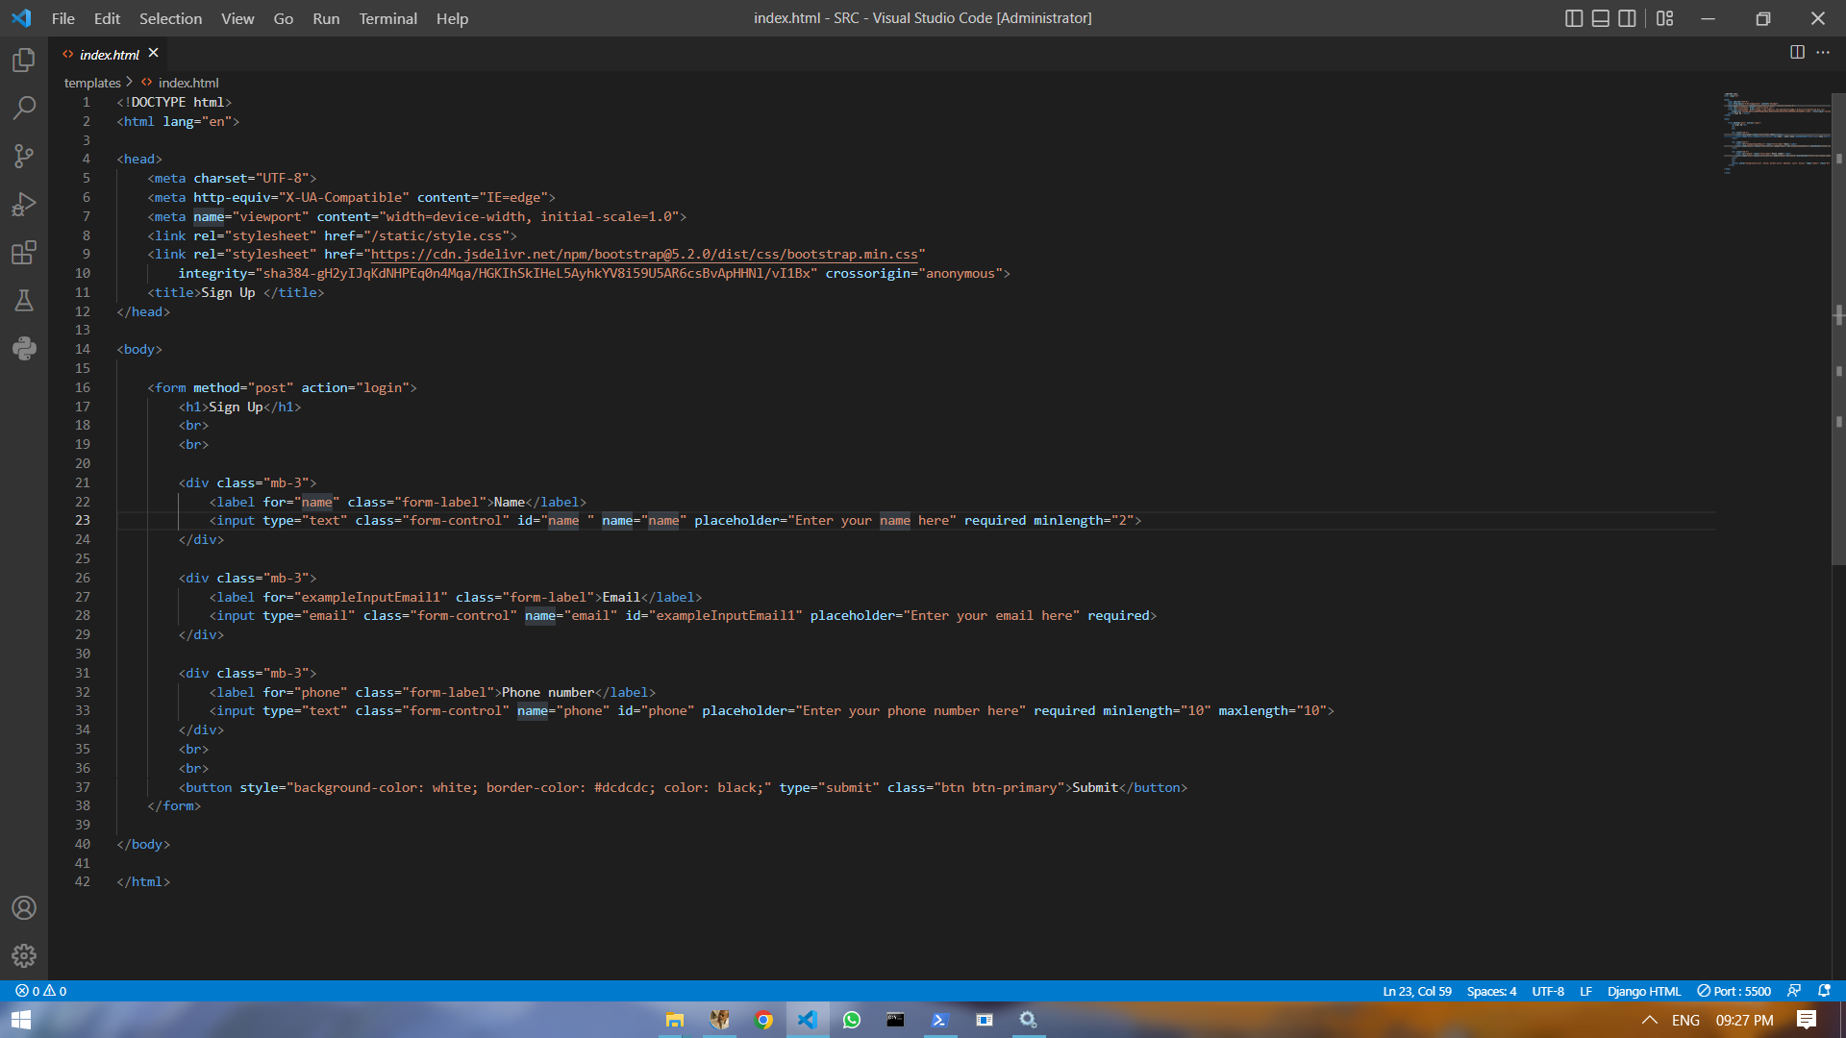

**Style.css**

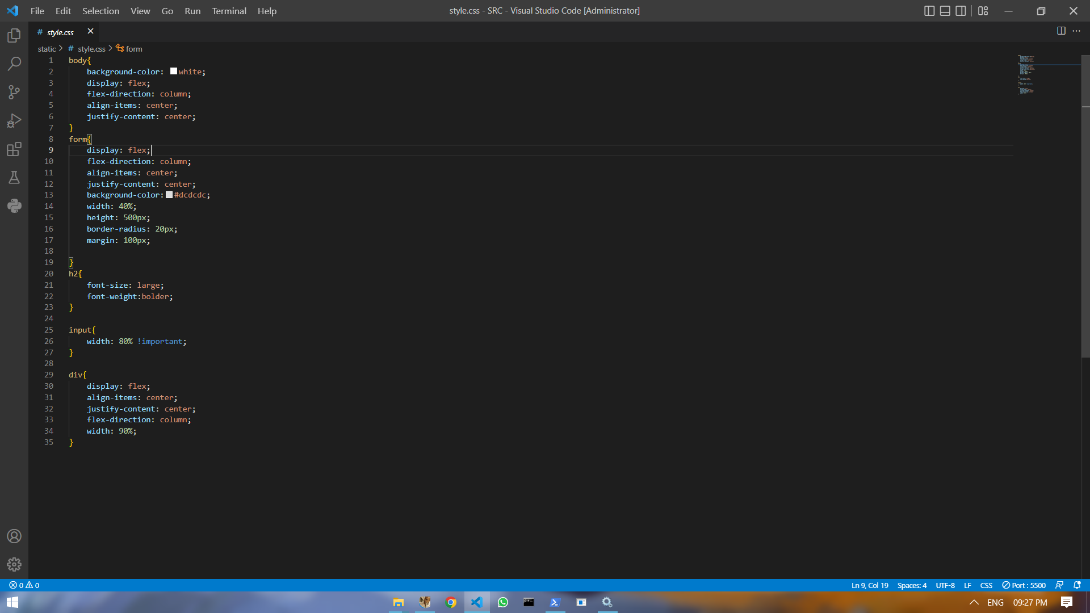

**Output: - Index Page:-**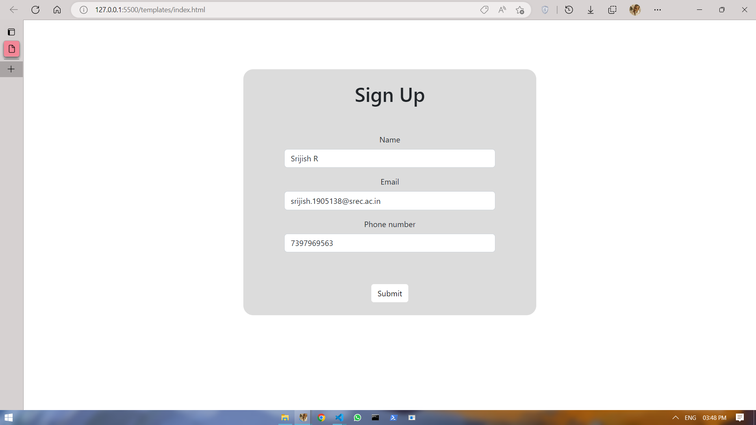

# Login successful page:-

# 